**Add User by Programmatic Access (Access Key and Secrete Key)**

: Click on add users

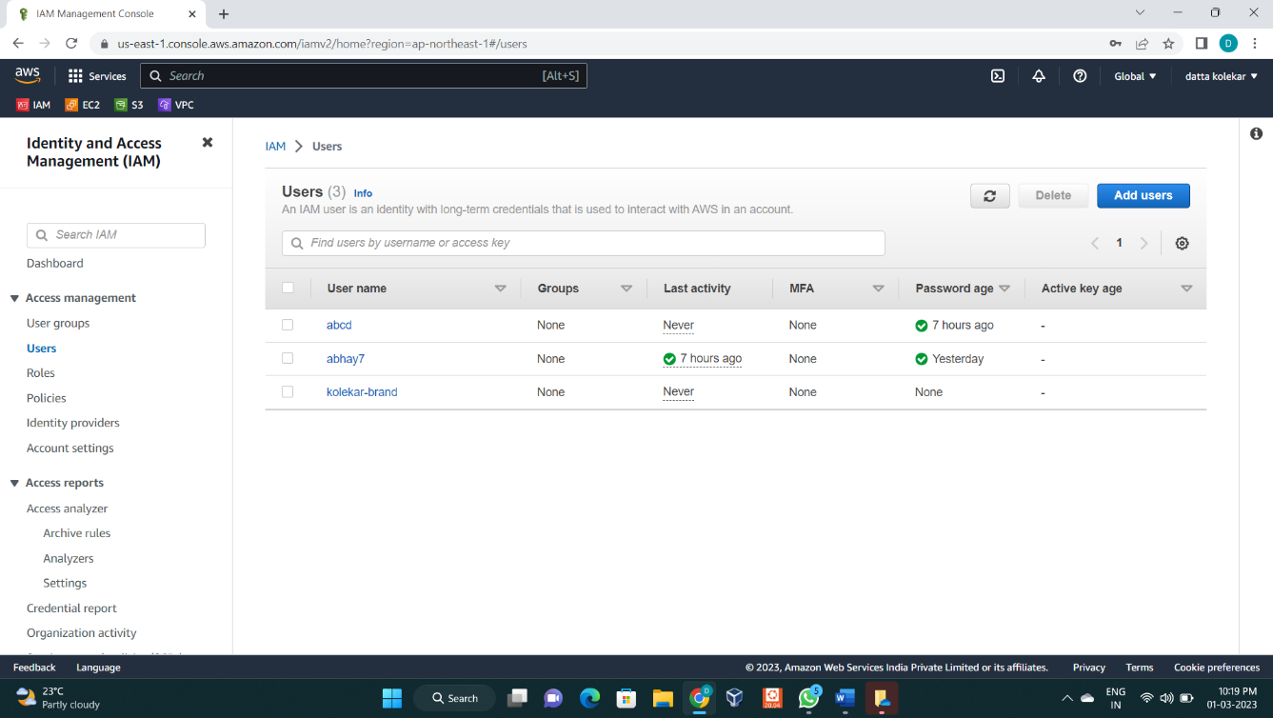

**Step 1**: Specify user details

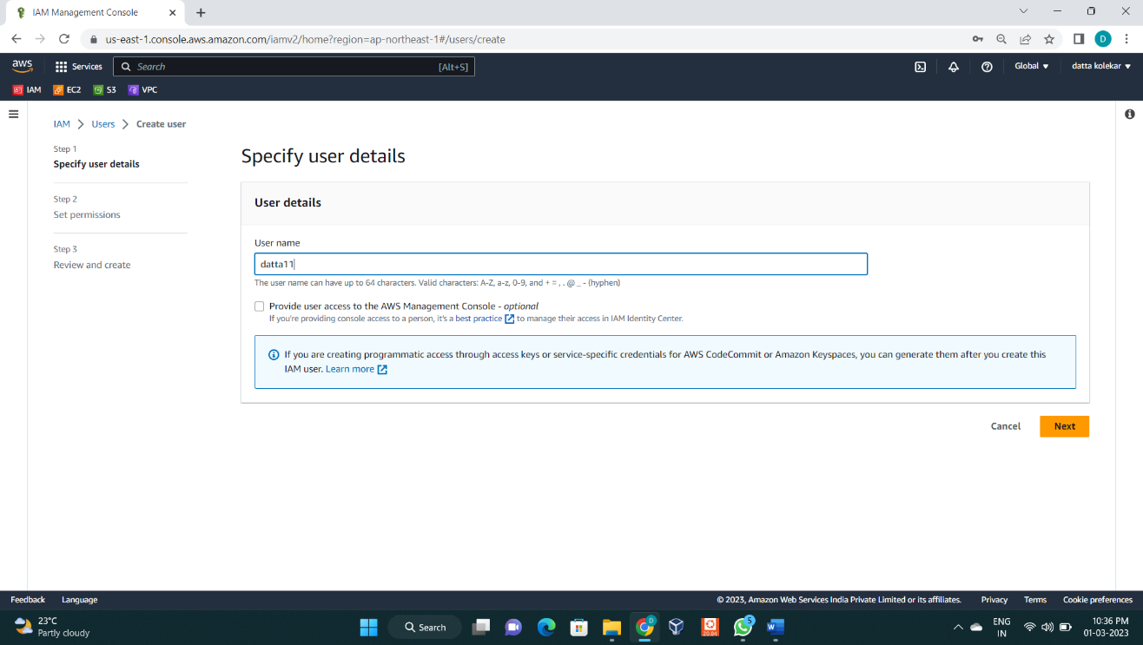

: Enter user name

: Do not enable **provide user access to the AWS management console**

**:** Click on Next

**Step 2:** Set permissions

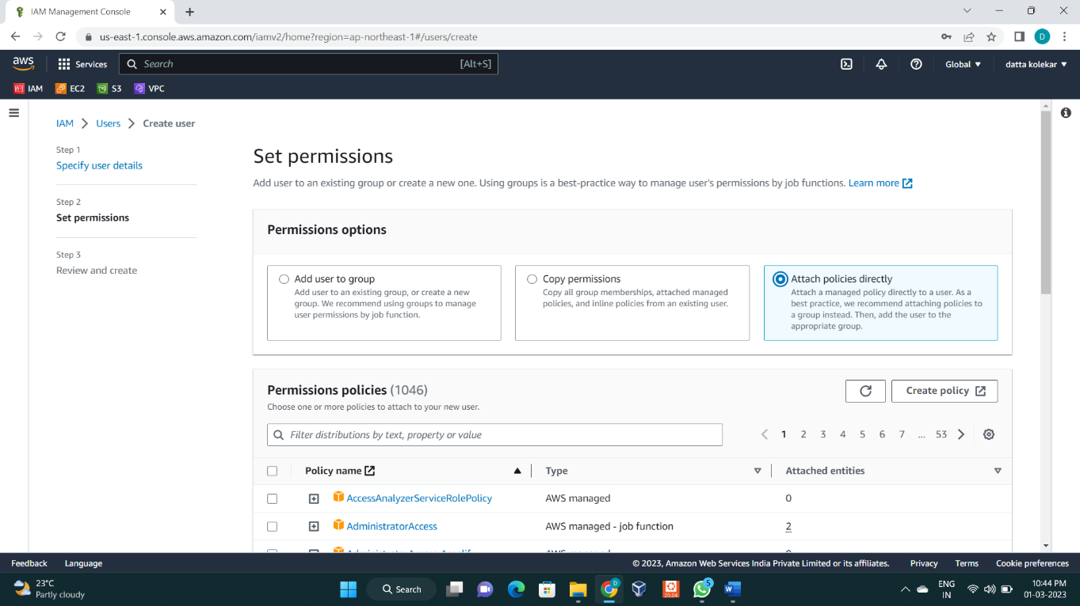

: Select attach policies directly

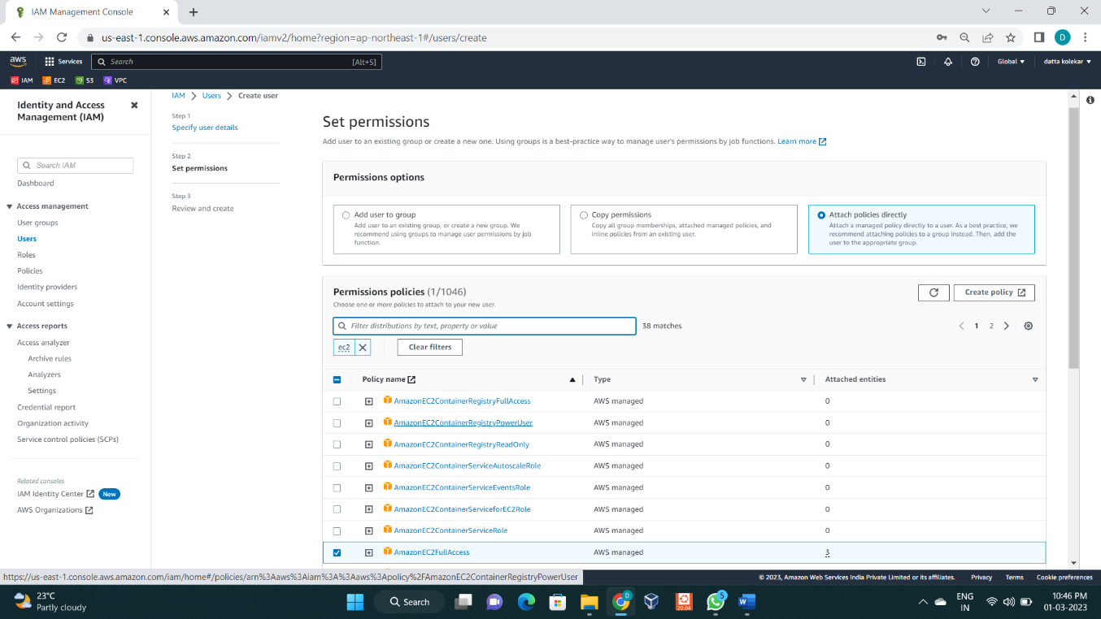

: In permission select **AmazonEc2fullaccess**

**Step 3:** Review and create

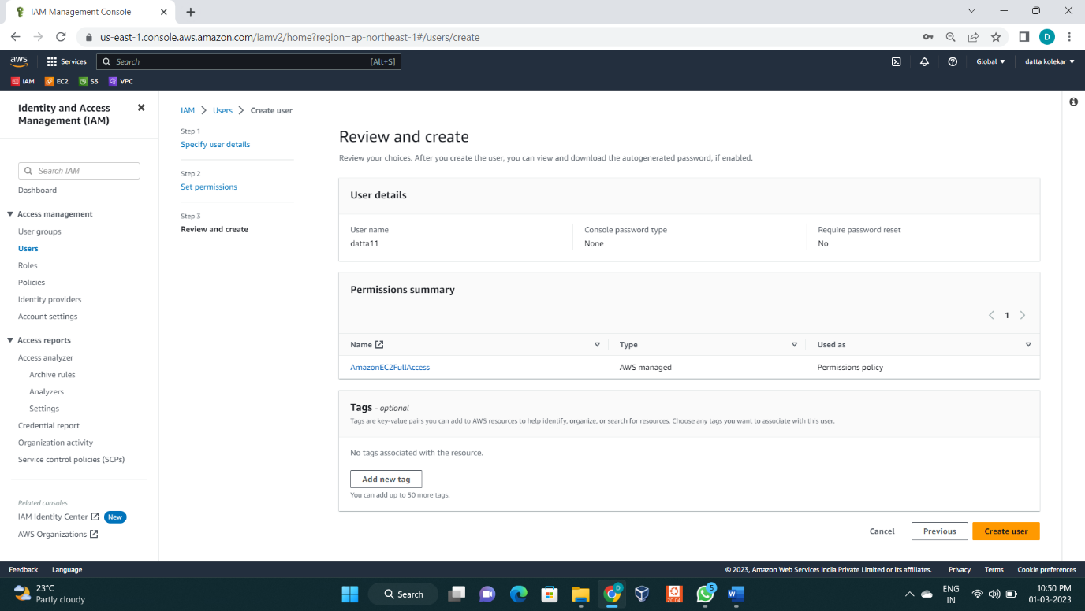

: Click on create user

: Now user **datta11** is created using programmatic access.

**To Create Access Keys**

: Click on username **datta11** from users list.

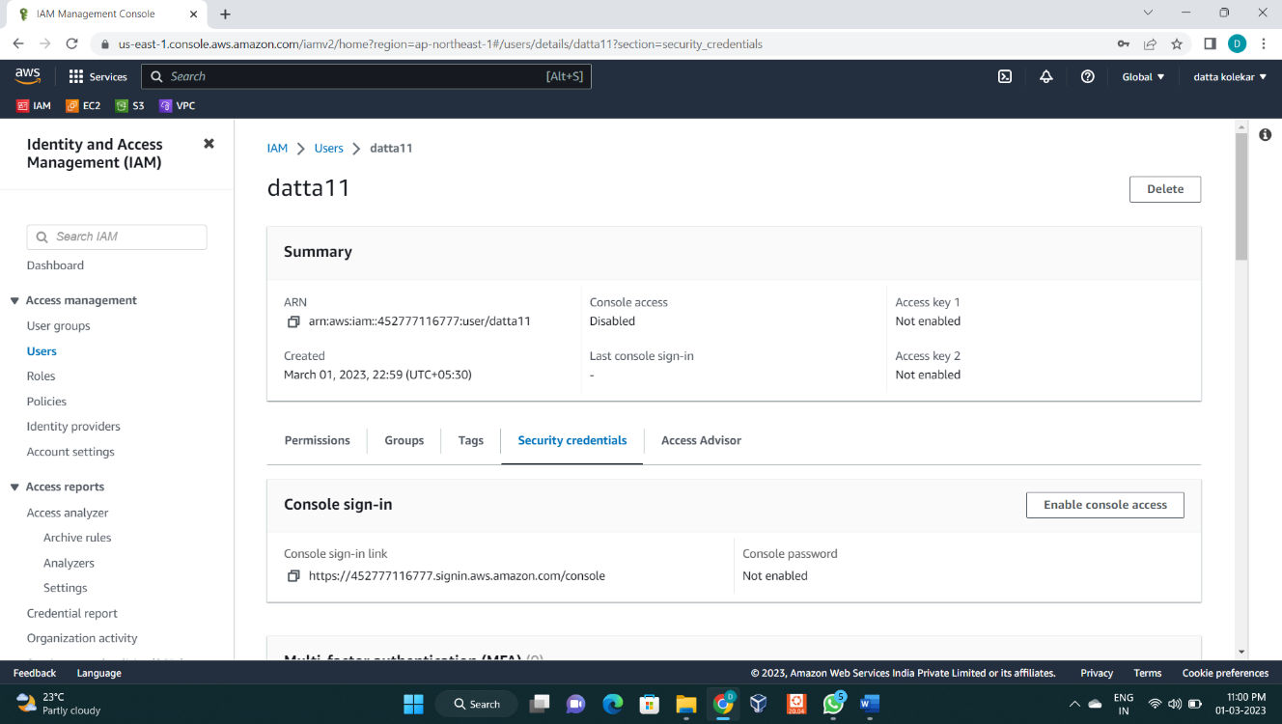

: Then click on **Security credentials** and scroll down to **Access Keys** option.

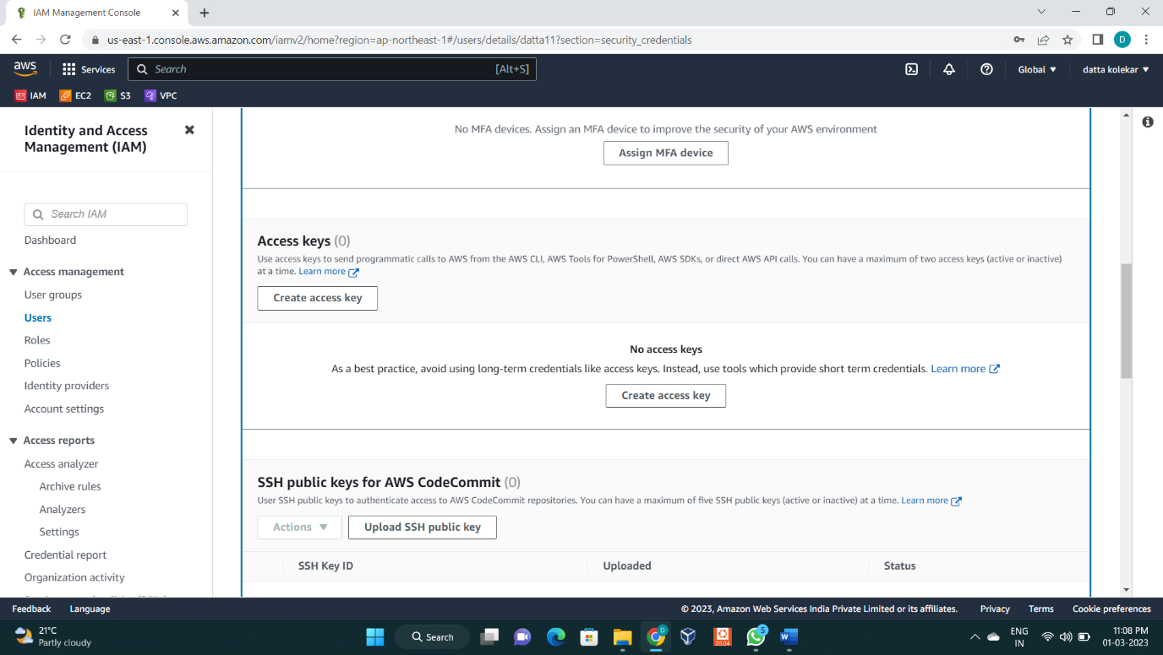

: Click on **Create Access key**

**Step 4:** Access key best Practices and Alternatives

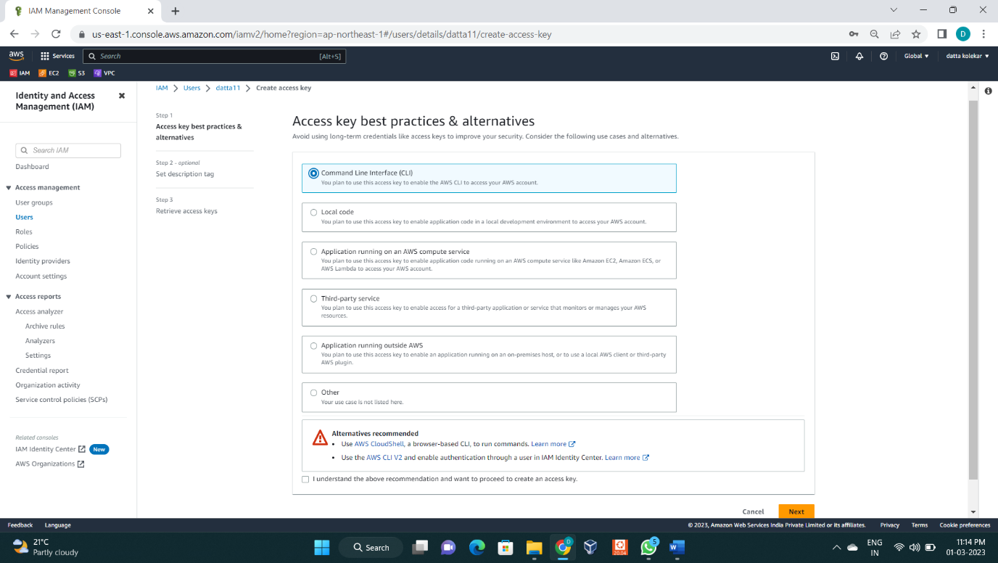

: Select Command Line Interface (CLI)

: Then click Next.

**Step 5:** Retrieve access keys

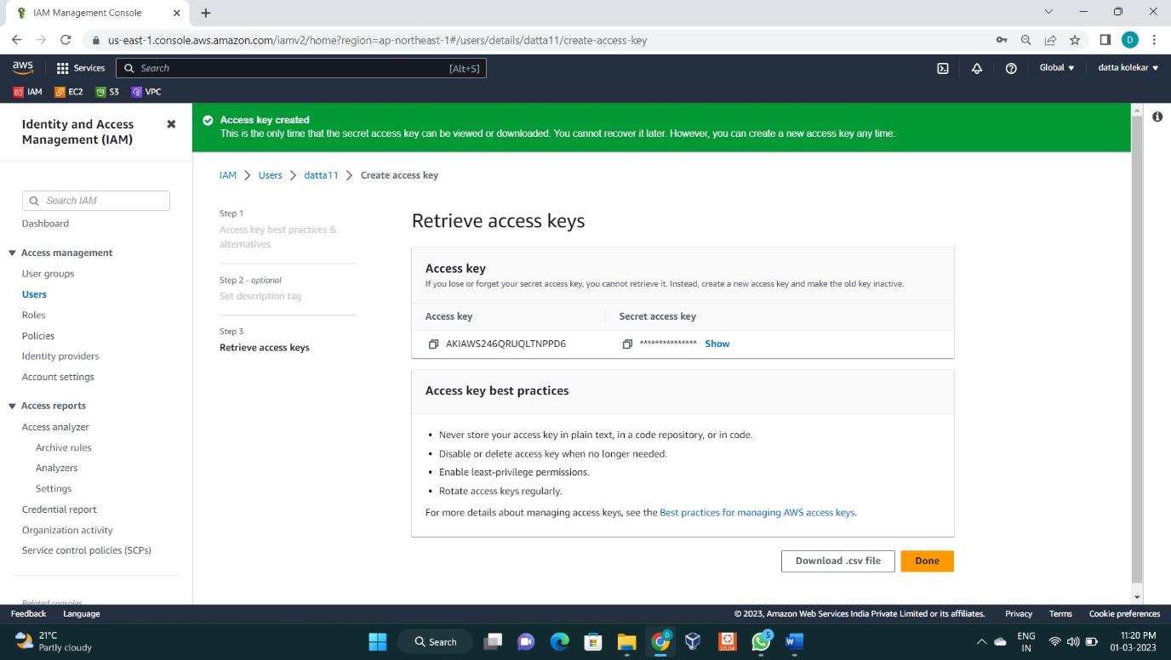

: So now we Download .csv file or copy Secrete key and Access key.